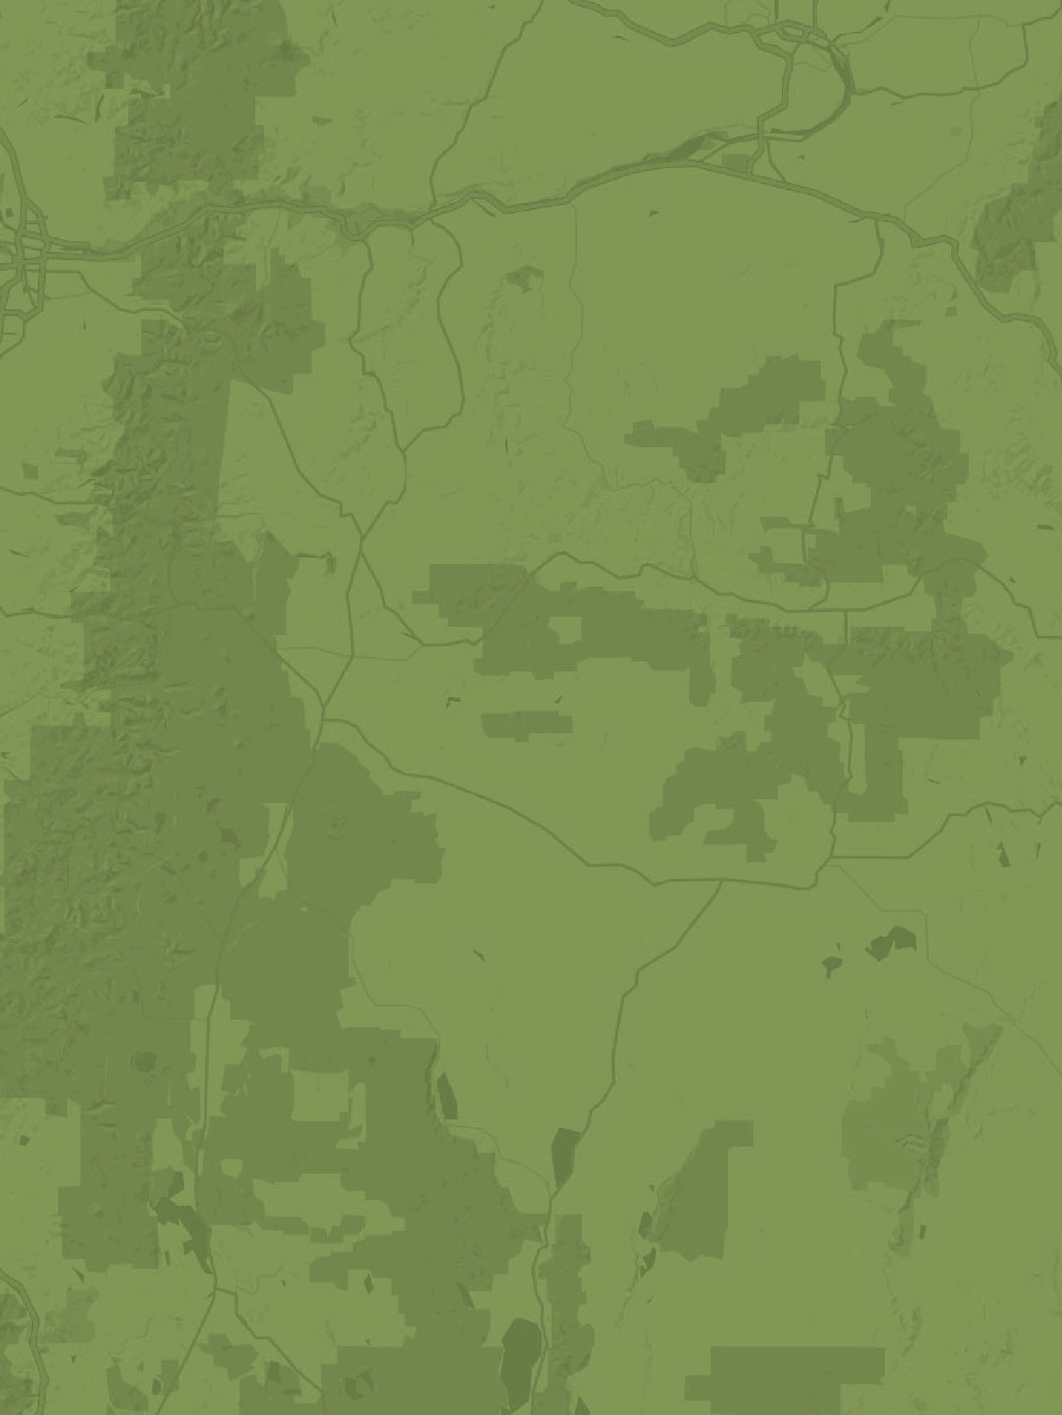

The Oregon Statewide
Action Plan for Invasive Species

2024 - 2026

WORKING DOCUMENT
DEVELOPED BY The:

OREGON INVASIVE SPECIES COUNCIL
Oregon Statewide Action Plan for Invasive Species 2017-2019 1

2

Oregon Statewide Action Plan for Invasive Species 2017-2019 | V1 | Updated July 5, 2017

EXECUTIVE SUMMARY

As globalization increases and the world becomes more accessible, invasive species pose a threat to key sectors of Oregon’s economy that depend upon natural resources and native ecosystems. Agriculture, forestry, tourism, and water resource infrastructure, including hydropower facilities, are at serious risk of being adversely impacted by invasive species.
Because invasive species are a constant threat and the pressure is unrelenting, proactive and coordinated management is necessary to sustain Oregon’s working landscapes and economic viability. Unchecked, invasive species individually and collectively have the potential to imperil public health and transform ecosystems, resulting in widespread economic and environmental devastation. Once introduced and established, many invasive species cannot be eradicated and the invasion itself becomes irreversible.
In addition, millions of species could be harmful to Oregon in ways we have not begun to assess. Preventing new introductions of invasive species, and removing and managing existing invasive species, requires constant vigilance. This task is possible only with the active cooperation of a strong network of diverse partners.
In 2001, the Oregon Legislature established the Oregon Invasive Species Council (“OISC” or “Council”) to conduct a comprehensive and coordinated effort to prevent, detect, control, and eliminate invasive species harming the region’s economy, health, and natural resources.

To read the accompanying plan, The Oregon Statewide Strategic Plan for Invasive Species 2017–2027, visit www.oregoninvasivespeciescouncil.org.

Oregon Statewide Action Plan for Invasive Species 2017-2019 3

DEFINITIONS

KEY PLAYERS: A governmental agency or other organization that is significantly engaged in implementing actions under the objectives on a statewide basis or whose efforts the Council recognizes as significantly advancing a statewide objective.

This role involves implementation, statewide tracking, participation and collaboration to ensure that Oregon achieves the objectives. The active coordination and collaboration by Key Players with the Oregon Invasive Species Council is essential for protecting Oregon from invasive species.

PARTNERS: A governmental agency or other organization that has contributed to invasive species efforts and demonstrated commitment to achieving the statewide objectives.

This role includes varying levels of implementation, statewide tracking, participation and collaboration to ensure that Oregon achieves the objectives. Partners are invited and encouraged to coordinate with the Oregon Invasive Species Council. Active coordination and collaboration among diverse partners provides the strongest foundation for protecting Oregon from invasive species.

OREGON INVASIVE SPECIES NETWORK: All key players, partners and any entity or individual with a stake or interest in protecting Oregon from invasive species. The Oregon Invasive Species Network (OISN) serves as hub for collaboration and coordination across the spectrum of invasive species efforts. The active involvement of network members determines the usefulness of the network.

INVASIVE SPECIES CHAMPION: An individual or representative of an organization who has made a significant contribution to advancing one or more statewide objectives at a local, statewide or regional scale.

OBJECTIVE I

PREVENTION
- Prevent the introduction and establishment of invasive species to reduce their impact on the environment, economy, and health of Oregon.
- Maintain exclusion of harmful invasive species.

Implementation: A robust communication and planning network for the state agencies, with emphasis on a pathways approach, will enhance the opportunity to succeed in preventing invasive species from entering Oregon. Adequate funding is essential for State and Federal agencies to be able to continue to lead prevention efforts.

KEY PLAYERS
Oregon Department of Agriculture
Oregon Department of Environmental Quality Oregon Department of Fish and Wildlife Oregon Department of Forestry
Oregon Department of Transportation Oregon State Marine Board
Tribal Governments
USDA Animal and Plant Health Inspection Service
U.S. Fish & Wildlife Service
Oregon Invasive Species Council

PARTNERS
Bureau of Land Management Cooperative Weed Management Areas
Consumptive users: anglers, hunters, trappers
Industry groups: agriculture, aquaculture, forestry, nursery, trade Law enforcement
National Park Service
Non-consumptive users: campers, hikers, photographers, sightseers Oregon State Parks
Oregon State University
Oregon Watershed Enhancement Board Portland State University
Travel Oregon
U.S. Customs and Border Protection
U.S. Forest Service

PREVENTION STRATEGY 1
Endorse pathway management to prevent introduction and establishment of new species into Oregon and to contain further spread of invasive species established within geographically limited areas of Oregon.

I.b. Facilitate a comprehensive evaluation of current laws, regulations & policies in place in Oregon to determine gaps and overlap for prevention of invasive species.

Report to the state legislature’s natural resource committee on or before December 2025 with recommendations based on a completed review of state invasive species efforts if HB 4148 is approved by the 2024 Legislature.

PREVENTION STRATEGY 2
Enhance enforcement by Oregon agencies of existing legal authorities that prevent introduction and spread of invasive species; evaluate changes needed to incorporate pathway approach into existing legal authorities.

  - Expand AIS inspection program to prevent introductions at state interior waterbodies and at all border entry points by seeking new state funding.

  - Evaluate what changes to laws, regulations, and policies are needed for cross- jurisdictional prevention and enforcement.

PREVENTION STRATEGY 5
Engage in cooperative partnerships at the local, national, and regional levels to aid in effective prevention.

  - Develop and adapt cooperative partnership models with industries and stakeholder associations operating in transportation pathways.

  - Coordinate shared regional messaging.

OBJECTIVE II

EARLY DETECTION & RAPID RESPONSE (EDRR)

- Strengthen and expand the capacity to identify, report, and effectively respond to newly discovered invasive species of all taxa.

Implementation: Early detection and rapid response (EDRR) is a critical component of successful invasive species management in Oregon. EDRR demands a widespread and comprehensive network of trained detectors and “boots on the ground” to implement rapid response strategies. The Oregon Invasive Species Council is well-positioned to convene diverse stakeholders to coordinate planning, research, and management of all invasive species. Local support and access to funding for rapid response is necessary to achieve eradication in the short time frame before an invading species is able to establish itself.

KEY PLAYERS
Oregon Department of Agriculture Oregon Department of Fish and Wildlife Oregon Department of Forestry
Oregon Invasive Species Council Tribal Governments
USDA Animal and Plant Health Inspection Service

PARTNERS
Army Corps of Engineers Bureau of Land Management Citizen Science Groups
Consumptive users: anglers, hunters, trappers Cooperative Weed Management Areas Hydropower facilities
Industry groups Local Governments National Park Service
Natural resource contractors
Non-consumptive users: campers, hikers, photographers, sightseers Oregon Department of Environmental Quality
Oregon Department of State Lands Oregon Department of Transportation Oregon Office of Emergency Management Oregon State Parks

Oregon State Marine Board Oregon State University
Oregon Watershed Enhancement Board Portland Bureau of Environmental Services Portland State University
Port management organizations Private landowners
Soil and Water Conservation Districts
U.S. Customs & Border Protection
U.S. Fish & Wildlife Service
U.S. Forest Service Watershed Councils Weed Control Districts

EDRR STRATEGY 1
Foster diverse early detection and rapid response (EDRR) networks emphasizing pathways, cross-jurisdictional partnerships, and sharing information.

  - Convene regional stakeholders annually to address pathway threats.

  - Develop a network model to assess network needs, increase efficiencies and effectiveness in communication and response.

EDRR STRATEGY 3
Facilitate comprehensive development of rapid response plans and capacity of collaborative response teams.

  - Expand Incident Command System for invasive species response including IS-ICS Teams.

  - Conduct tabletop drills and exercises at network meetings to test and adapt the response network.

EDRR STRATEGY 4
Support targeted survey and monitoring efforts using a pathway analysis and a partnership approach.

  - Seek funding for local districts to enhance EDRR capacity and create consistency across the state.

  - Maintain consistent funding and support for invasive species hotline.

  - Promote reporting and mapping of invasive species observations via use of existing resources in one central location.

  - Seek funding to increase state invasive species control account from $350,000 to
$5 million.

OBJECTIVE III

CONTROL & MANAGEMENT
- Minimize the harmful impacts of established invasive species populations through containment, reduction, and effective management.
- Prevent the spread of established invasive species.

Implementation: Natural resource agencies, local governments and control districts, and NGOs play a critical role in protecting our natural resources from the devastating effects of invasive species. On-the-ground partners are fighting an uphill battle on a daily basis. Control and management requires stable funding, research into new control methods, and cooperation from landowners in the state.

KEY PLAYERS
Bureau of Land Management Cooperative Weed Management Areas Land managers
National Park Service
Oregon Department of Agriculture Oregon Department of Fish and Wildlife Oregon Department of Forestry
Oregon Department of Transportation Oregon Department of State Lands Oregon State Parks
Private landowners
Soil and Water Conservation Districts Tribal Governments
USDA Animal and Plant Health Inspection Service
U.S. Fish & Wildlife Services
U.S. Forest Service
Oregon Invasive Species Council

PARTNERS
Army Corps of Engineers Local Governments
Natural resource contractors NGOs
Oregon Department of Environmental Quality Oregon State Marine Board
Oregon State University
Oregon Watershed Enhancement Board Port management organizations
Private landowners Watershed Councils Weed Control Districts Portland State University

Research institutions

CONTROL & MANAGEMENT STRATEGY 2
Identify and secure sufficient funding for effective invasive species control.

  - Increase current levels of funding for invasive species control, including funding invasive species control districts.

  - Collaboratively develop a strategy for new sources of funding for invasive species control.

  - Investigate and compile information about the economic implications of invasive species impacts to demonstrate the importance of control.

OBJECTIVE IV

EDUCATION & OUTREACH

- Ensure all Oregonians have an understanding of the impacts of invasive species and what role they can play in preventing and controlling invasive species.

Implementation: Research institutions, county extension offices, and NGOs are at the forefront of education and outreach, reliant on natural resource agencies for up-to-date information and resources. Diverse partnerships are extremely important to extend the reach of information to many different audiences. Shared messaging, user-friendly access to resources, and culturally diverse messages create a robust infrastructure for disseminating information widely.

KEY PLAYERS
Oregon Invasive Species Council Oregon Sea Grant
Oregon State University Portland State University Tribal Governments

PARTNERS
k-12 Educators
Colleges and Universities Community groups Media Outlets
NGOs (such as Dig In, Friends of Outdoor School, Northwest Youth Corps, SOLVE, Willamette Riverkeepers) Nonformal educators
Oregon State University Extension Outdoor retailers
Pet trade organizations Bureau of Land Management National Park Service
Oregon Department of Agriculture
Oregon Department of Environmental Quality Oregon Department of Fish and Wildlife Oregon Department of Forestry
Oregon State Marine Board Oregon State Parks
USDA Animal and Plant Health Inspection Service
U.S. Fish & Wildlife Service
U.S. Forest Service

EDUCATION & OUTREACH STRATEGY 1
Expand awareness of invasive species through messaging and improved communication tools that meaningfully reach the Oregon public.

  - Engage with the general public through varied events and publicity including National Invasive Species Week, presence at highly attended events such as the Oregon State Fair, press & media relations, along with social media and video projects.

  - Implement an education and outreach grant program to increase broad-based public awareness of the threats and impacts of invasive species and instill personal responsibility and protection of Oregon’s natural resource assets.

  - Plan and coordinate field day education events to increase engagement with policymakers.

EDUCATION & OUTREACH STRATEGY 2
Collaboratively develop educational materials with network partners to leverage expertise and resources.

  - Increase educational signage across the state.

  - Coordinate between outreach and education partners to leverage funding and capacity.

  - Compile, assess, and refine culturally and geographically-relevant educational materials using a variety of media, including professional materials, shared messaging, and best available materials.

  - Compile and share data on social, environmental, and economic impacts of invasive species.

EDUCATION & OUTREACH STRATEGY 3
Promote focused, inclusive outreach and engagement to build public support and involvement among historically under-represented audiences

  - Engage a diverse network of Oregonians through on-the-ground community efforts.

  - Engage with communities directly through clubs, schools, and other organizations that serve underrepresented Oregonians.

  - Coordinate between partner education organizations and outreach organizations to leverage reach and capacity.

  - Develop a cooperative partnership with tribal governments to create and disseminate educational invasive species messages.

OBJECTIVE V

COORDINATION & LEADERSHIP

- Maximize cross-organizational effectiveness and collaboration.
- Coordinate a comprehensive invasive species network in the state and region to deal with invasive species spanning jurisdictional boundaries.
- Leverage funding opportunities and elevate the understanding of threats and risks of invasive species.

Implementation: Coordination will take multiple forms, but the foundation of success resides in strong cooperation and support from both the top down and bottom up. Leadership plays a central convening role to bring together diverse stakeholders in a variety of ways, support working groups across sectors, and provide a central online clearinghouse for information.

KEY PLAYERS
Governor’s Natural Resources Office Oregon Invasive Species Council
Oregon Invasive Species Council Advisory Committee Oregon Legislators
Tribal Governments

PARTNERS
Bureau of Land Management Cooperative Weed Management Areas Idaho Invasive Species Council Industry leaders
National and Regional Invasive Species Councils NGOs
Northwest Power and Conservation Council Oregon Office of Emergency Management Pacific NorthWest Economic Region
Pacific States Marine Fisheries Commission Soil and Water Conservation Districts National Park Service
Oregon Department of Agriculture
Oregon Department of Environmental Quality Oregon Department of Fish and Wildlife Oregon Department of Forestry
Oregon State Marine Board Oregon State Parks
U.S. Customs and Border Protection

USDA Animal and Plant Health Inspection Service
U.S. Fish & Wildlife Service
U.S. Forest Service
Washington Invasive Species Council

COORDINATION & LEADERSHIP STRATEGY 1
Establish and maintain an online information clearinghouse for invasive species.

  - Develop the Oregon Invasive Species Council website as a user-friendly, searchable public resource to access available information about invasive species and to allow information exchange.

  - Inventory available invasive species information and assess for duplication and omissions. Make recommendations for updating website to address duplication and omissions.

  - Develop a collaborative online hub for management efforts including planning, response plans, best management practices, data exchange, and strategic action plans.

  - Support exchange of survey data and strengthen statewide mapping initiatives.

COORDINATION & LEADERSHIP STRATEGY 2
Facilitate communication networks for sharing information and responding to invasive species threats.

  - Facilitate an annual meeting to complete tracking of implementation of the statewide strategic plan for all objectives.

  - Facilitate regional & pathway working groups, interactive network meetings, and other forms of collaboration between Council meetings to share information and enhance the invasive species network in Oregon.

  - Assess potential roles of a diverse advisory body and determine how to increase participation in invasive species issues across political and governmental lines.

COORDINATION & LEADERSHIP STRATEGY 3
Ensure adequate funding is available to effectively prevent, control, and manage the introduction and spread of invasive species.

  - Seek funding for a $5 million dollar invasive species emergency fund; include statutory protection from being “swept”.

  - Seek funding for the OISC Coordinator position sufficient to maximize and sustain statewide invasive species coordination and implementation of the Statewide Strategic Plan objectives.

COORDINATION & LEADERSHIP STRATEGY 4
Engage in collaborative planning to prioritize efforts.

  - Diversify Oregon Invasive Species Council’s advisory body for multi-stakeholder engagement and planning.

  - Make recommendations for legislation to address significant gaps in legal authorities.

COORDINATION & LEADERSHIP STRATEGY 5
Evaluate effectiveness of current invasive species programs and make recommendations for improvement.

  - Evaluate effectiveness of existing legal authorities (statutes & regulations).

  - Formulate performance measures and determine associated financial costs for implementation of existing invasive species programs.

COORDINATION & LEADERSHIP STRATEGY 6
Coordinate effectively between state agencies on all invasive species issues under the guidance of the Governor’s Natural Resource Office.

  - Utilize information from network and working groups to develop plans and priorities.

  - Coordinate with decision-makers including regularly scheduled briefings with key legislators.

  - Increase agency directors’ participation in Oregon Invasive Species Council functions.

  - Coordinate closely and routinely with Governor’s Natural Resource Office..

  - Make recommendations for legislation to address gaps in legal authorities.

RESOURCES

OISC REPORTS & SPONSORED PROJECTS
Oregon Invasive Species Council Action Plan 2012-2016 http://library.state.or.us/repository/2013/201303261307482/index.pdf
Assessment of Invasive Species in Oregon http://www.anstaskforce.gov/StatePlans/OR/statewidemanagementassessmentreportfi
nal.pdf
Top 100 Invaders to Keep Out https://www.oregoninvasivespeciescouncil.org/oregon-resources/
Oregon Invasive Species Hotline https://oregoninvasiveshotline.org
iMapInvasives
http://www.imapinvasives.org
Oregon Public Broadcasting: The Silent Invasion http://www.opb.org/programs/invasives/

STATE INVASIVE SPECIES MANAGEMENT RESOURCES
Oregon Department of Agriculture: Noxious Weeds http://www.oregon.gov/oda/programs/weeds/pages/aboutweeds.aspx
Oregon Department of Environmental Quality: Ballast Water Management Program http://www.oregon.gov/deq/Hazards-and-Cleanup/env-cleanup/Pages/Ballast-
Water.aspx
Oregon Department of Fish and Wildlife: The Oregon Conservation Strategy http://www.oregonconservationstrategy.org
Oregon State University: Oregon Forest Pest Detectors http://pestdetector.forestry.oregonstate.edu
Oregon State Marine Board: Aquatic Invasive Species Program http://www.oregon.gov/OSMB/boater-info/Pages/Aquatic-Invasive-Species-
Program.aspx
Western Invasives Network http://www.cascadepacific.org/western-invasives-network
Oregon Integrated Water Resources Strategy https://www.oregon.gov/owrd/LAW/docs/IWRS_Final.pdf

PACIFIC NORTHWEST KEY PLAYER & PARTNER RESOURCES
Pacific Northwest Weed Management Handbook https://pnwhandbooks.org/weed
The 100th Meridian Initiative: Columbia River Basin Interagency Response Plan http://100thmeridian.org/ActionTeams/Columbia/CRB%20Dreissenid%20Rapid%20R
esponse%20Plan%20OCTOBER%201%202008.pdf

2015 Washington Invasive Species Council Strategic Plan http://www.invasivespecies.wa.gov/documents/WISCStrategicPlan.pdf
Pacific Northwest Invasive Plant Council http://www.pnw-ipc.org/

FEDERAL KEY PLAYERS & PARTNER RESOURCES
United States Department of Agriculture: Invasive Species https://www.fs.usda.gov/main/r6/forest-grasslandhealth/invasivespecies
United States Fish and Wildlife Service: Pacific Region Aquatic Invasive Species https://www.fws.gov/pacific/fisheries/aquaticnus/index.cfm

REVISION HISTORY

Version 1: February 6, 2017

Version 1: February 14, 2017
- Added consumptive users under Prevention and EDRR
- Expanded list of industry groups
- Added USDA APHIS to multiple objectives
- Added U.S. Customs and Border Protection to multiple objectives

Version 1: July 5, 2017
- Added Washington and Idaho Invasive Species Council as partners under Coordination and Leadership
- Added Soil and Water Conservation Districts as partners under Early Detection Rapid Response
- Updated link for Top 100 Invaders

